Cody Williams

CSCE 465

09/18/19

Homework 2 report

2.1 Initial setup

Address space randomization:

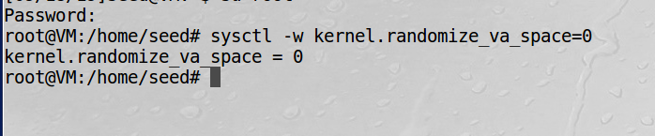

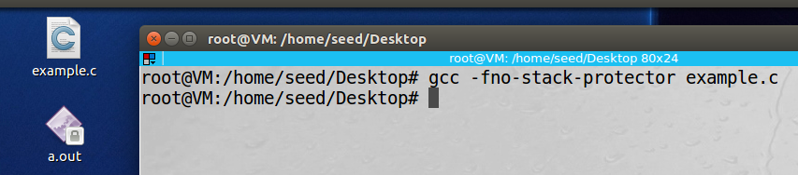 The StackGuard Protection Scheme:

 Non-Executable Stack:

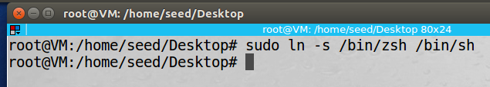 Configuring bin/sh for Ubuntu 16.04:

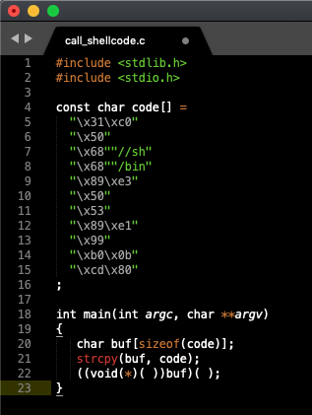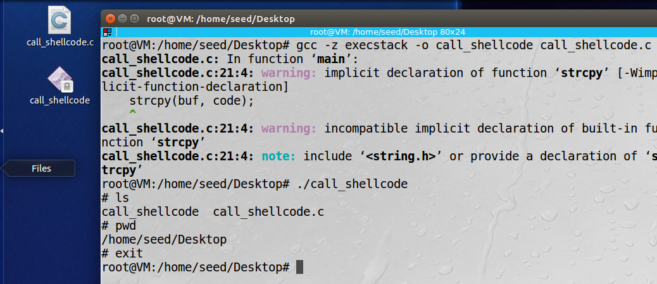2.2 Task 0 : Running Shellcode

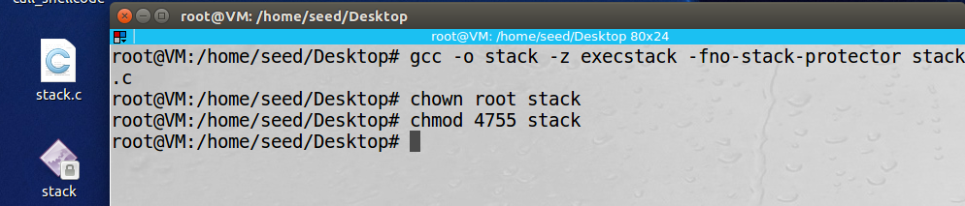2.3 The vulnerable program

2.4 Task 1 Exploiting the Vulnerability

exploit.c code stack.c code

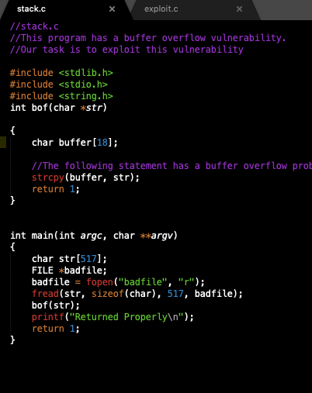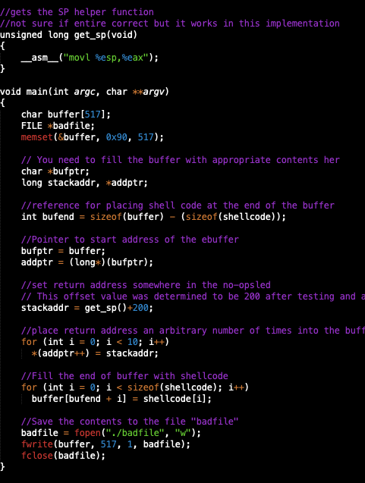

Compilation and Proof of Functionality

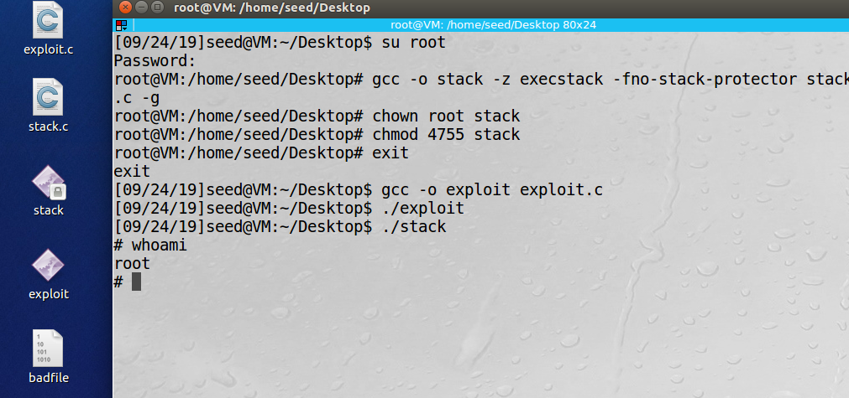

Explanation:

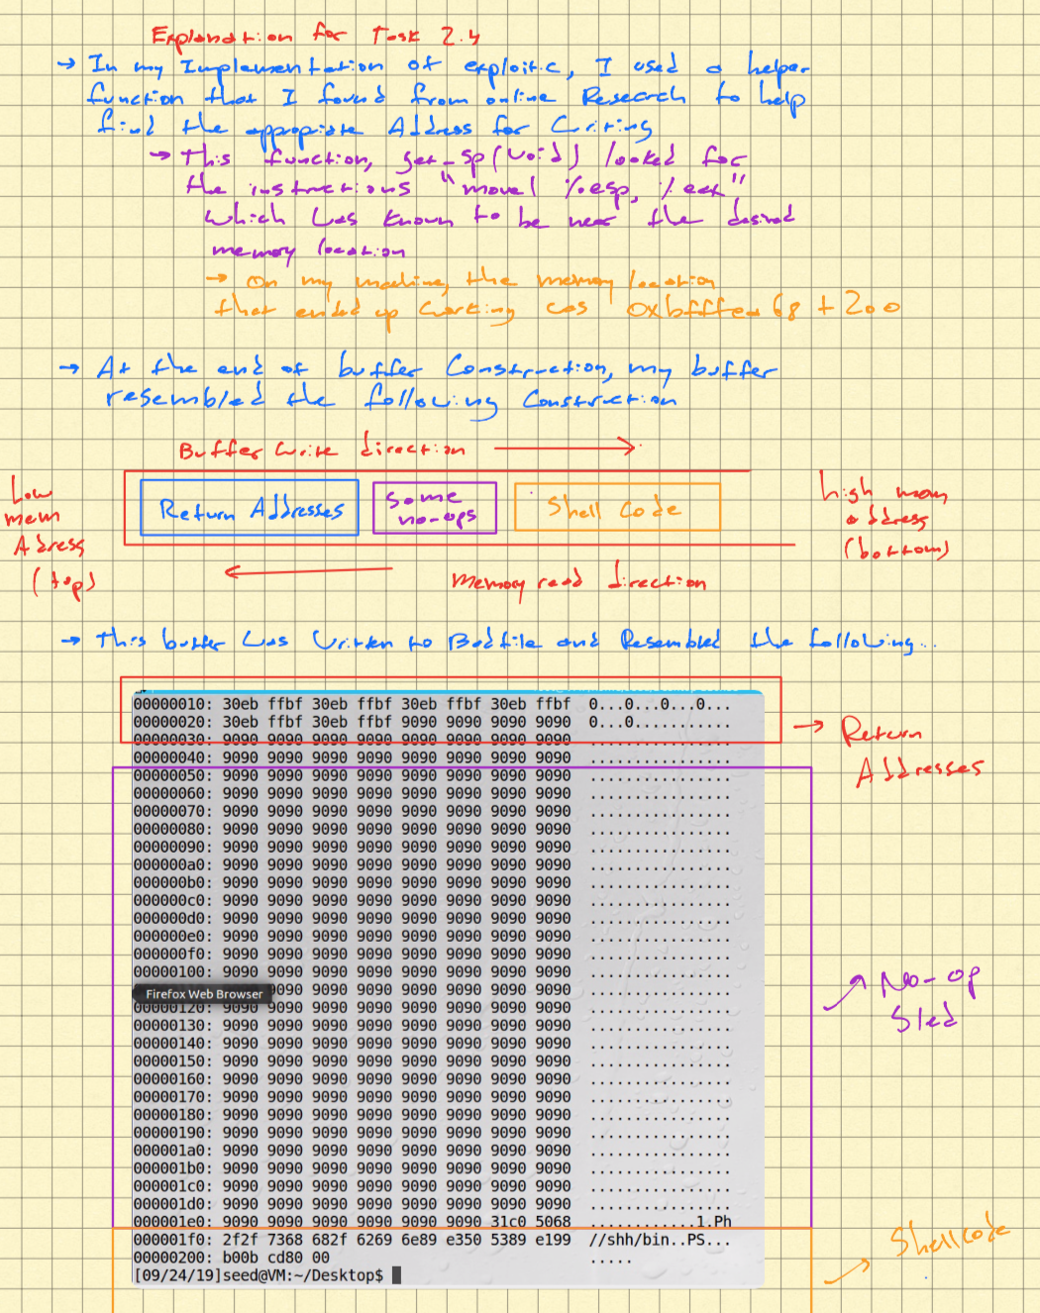

Changing to the rood user ID

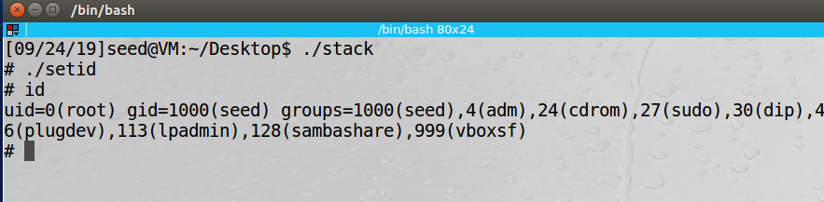

2.5 Task 2 Defeating dash’s countermeasure

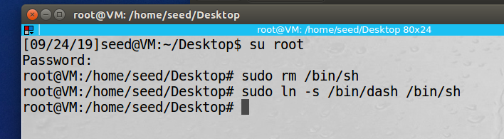Changing /bin/sh so it points back to /bin/dash

Running dash_shell_test.c

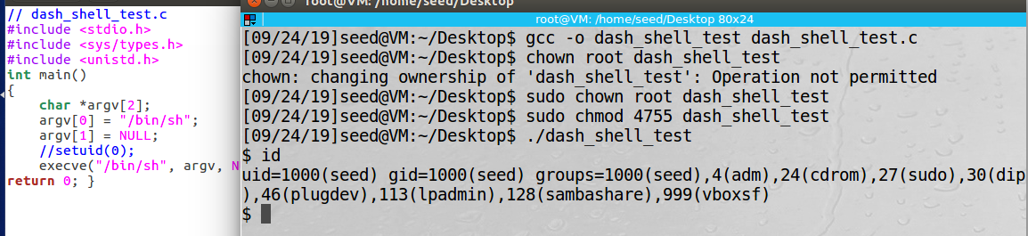with setuid(0) commented: The UID is seed. The shell produced is not a true root shell with root privileges

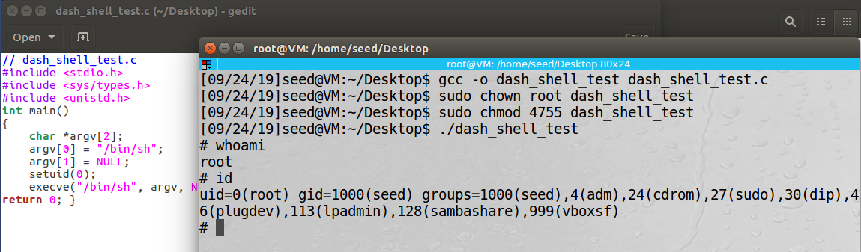with setuid(0) uncommented: The UID is root. The shell produced as a result of execution is a root shell with true root privileges.

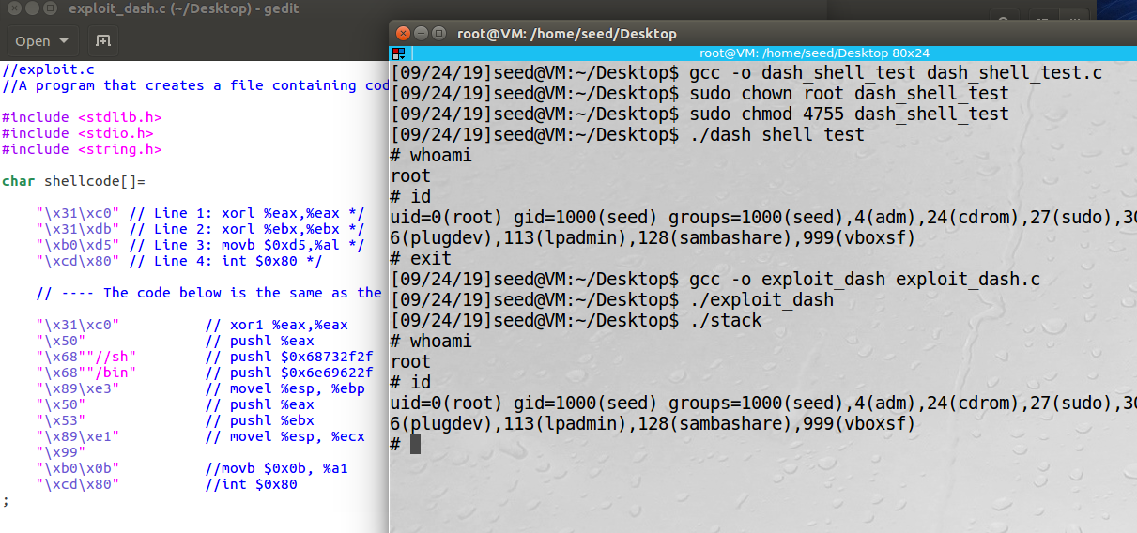Adding specified shellcode to exploit.c and attempting to exploit the vulnerable stack program : After adding the specified instructions to the exploit.c program (into a new file called (exploit_dash.c) the shell created upon execution of the vulnerability is a true root shell with uid = 0. This is not the case when the exploit.c program is run without the additional instructions.

2.6 Task 3 Address Randomization

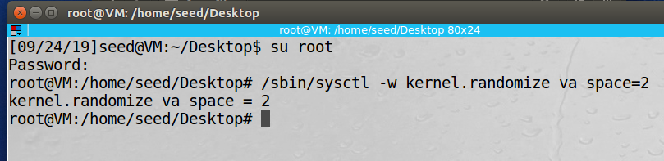Turning address randomization back on.

Attempting to run vulnerable stack a single time

Attempting to run stack multiple times using s h -c "while [ 1 ]; do ./stack; done;

* After letting the shell script attempt to execute the vulnerable stack for about 60 seconds, a shell was obtained. The shell was a seed shell because of the linkage to dash in the previous task and running the version of exploit.c that did not have the additional instruction to overcome the dash protection.
* In order to speed up the time taken to receive a shell when attempting to exploit stack with address randomization enabled, it would be beneficial to have a larger buffer and a larger no-op sled. With a larger no-op sled, the chances of forcing the vulnerable program to hit the range of no-op increases and the time taken to obtain a shell should, in theory, decrease.

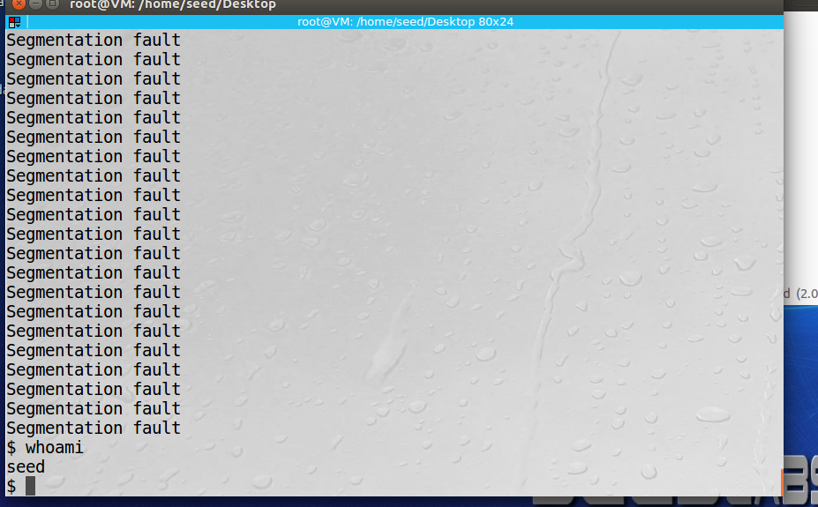

2.7 Task 4: Stack Guard

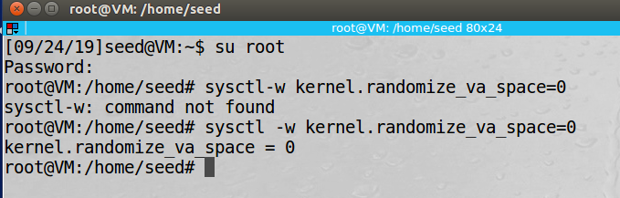Turning address randomization off again.

Recompiling stack program without stack guard and attempting to run exploit:

* After recompile without -fno-stack-protector and attempting to exploit the stack, the exploit no longer works
* 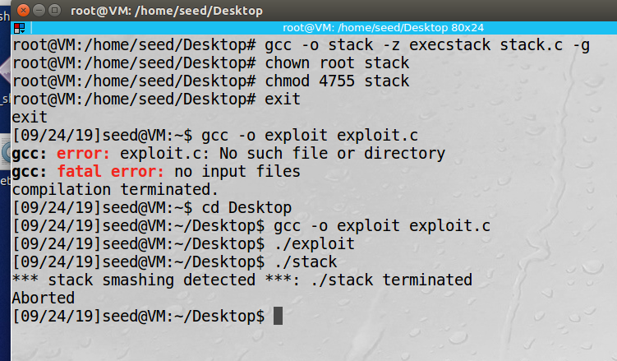In this trial of the exploit, the exploit fails to work because the stack protector is enables and aborts the execution with “*** stack smashing detected ***”.

2.8 Task 5: Non-Executable Stack

Recompiling and attempting to exploit with non-executable stack

* When the program is compiled with a non-executable stack, the program will continuously return segfault errors
* 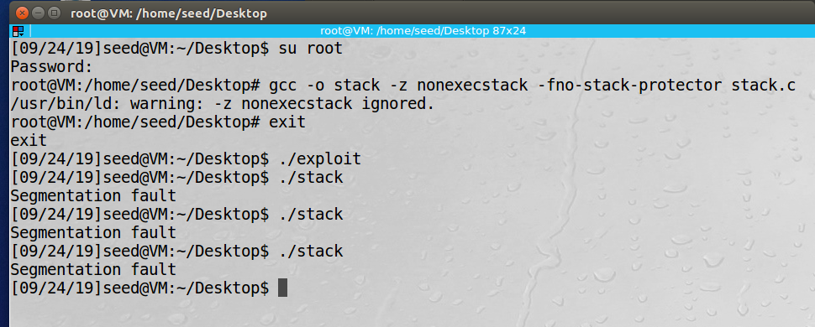This happens because the non-executable stack protection marks certain areas of the program’s memory space as non-executable. In this case, the badfile code attempting to be executed lies in one of the memory areas that is designated as a non-executable, and therefore will not be able to be executed as part of an exploit. Although this is an effective measure against buffer overflow attacks, the stack is still vulnerable to attack such as “return to libc” that attack the stack directly.